Most Venerable “Bhante Vimalaramsi Mahathero,
USA Rep. for World Buddhist Summit Conference
We don’t talk much about who we are and what we are doing deep in the forest in Missouri away from everything. It isn’t that we don’t want to tell you. WE just keep on going with the Dhamma. Soo, this year, 2017, I decided to take this opportunity during this Conference to put together this STORY BOARD so that you could take a leisurely online tour covering some different years til now and see some of the history and scenes of the Dhamma Sukha Meditation Center and Monastery in the Ozark Mountains in Missouri which, is supported by United International Buddha Dhamma Society in the USA. I sincerely hope seeing where we are and how simply we live at the center will inspire you to come and visit one day.. It is a perfect setting for building a solid meditation Practice to carry you through your life and reach the final objective as well, Nibbana. .
Where are we.

Fall 2011- DSMC News Up-date--- by Rev. Sister Khema  Dhamma Sukha Meditation Center  DSMC  Annapolis, Missouri  USA | 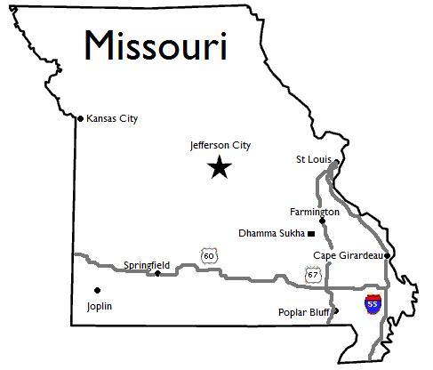
There is a piece of land fully paid for now that holds 103 acres of land and still has plans for development within our plans. From the Satellite it looks like this on Google Global Earth—on the Left side is the Monastics live. The Center cluster is the Meditation training for personal retreats. On the Right side with the circle drive is the location of the old mill property with 42 acres turned over to Sister Khema to build a future Women’s retreat and life coaching Center. SK

Full 103 acres of Dhamma Sukha Meditation Centre Property
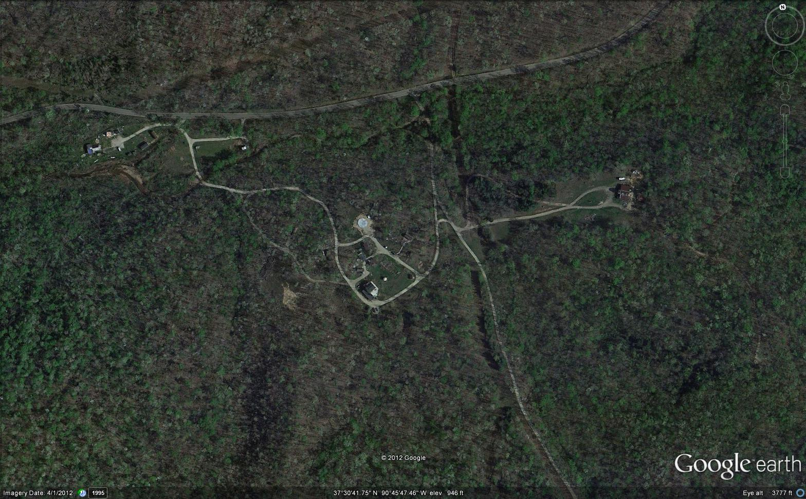

20 acres first three years. 15 added and 10 more given with a high point for future Memorial Pagoda. 76 more acres with the Mill site added on later. Entire mortgage paid off after 8 years time. No debt on land.

DSMC Story board
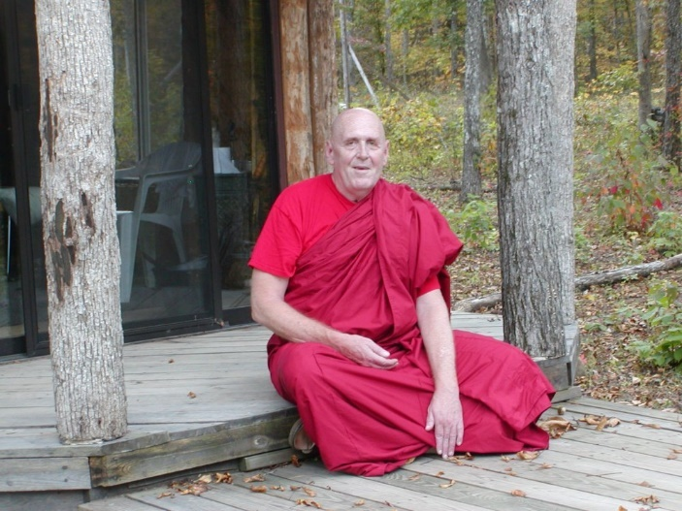 | -  DSMC 1st forest kuti  built by  Ven. Bhante Vimalaramsi  &  Venrable U Jatika  2005
A happy tree  &  Blessed Monk in S.Korea!  2006 | 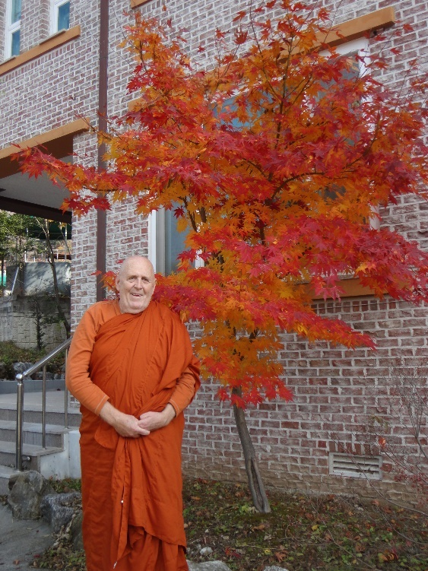
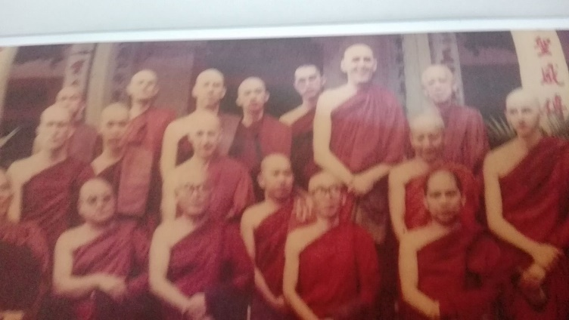 | Bhante Vimalaramsi in the back row here, 3rd from right, following the two-year retreat in Burma with U Padita- 1990s

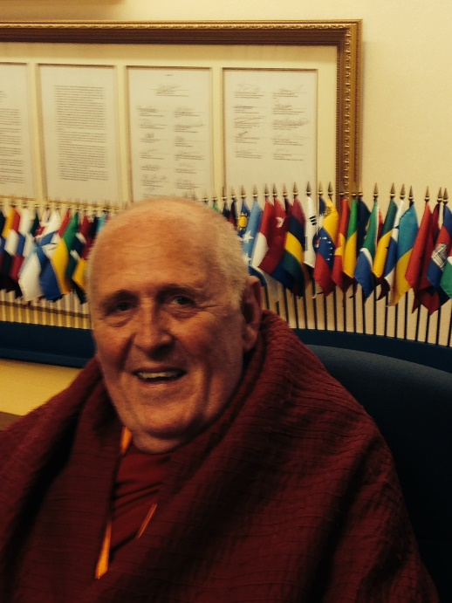  Picture taken in 2014 | 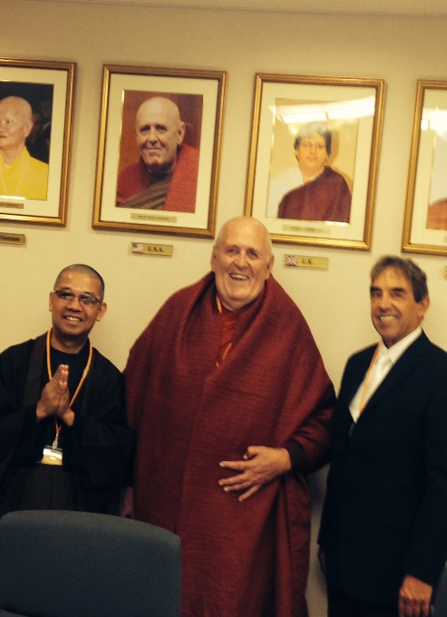  In the Offices of World Buddhist Summit Council in Kobe, Japan.

Short BIO
Most Venerable Bhante Vimalaramsi MT.
Today, in Asia, he is H.H. Most Venerable, SayadawGI, Sasana Tilakana, “Bhante” Vimalaramsi , but for all of us in America, a frontier Buddhist nation, for those whom he has faithfully taught for so many yeare, he will always be our teacher, “Bhante V”.
Most Venerable “Bhante” Vimalaramsi Mahathero began in Espandito, California, USA as “Marvel Logan”. He followed his curiosity and studied first with Anagarika Munindra in 1977. He served as personal assistant for the late Most Venerable U Silinanda for 2 yrs and then became a bhikkhu in Thailand in 1986; In Burma he completed a 2 yr retreat with U Pandita. He investigated several teachers in Thailand; and spent nearly 3 yrs in Malaysia with Venerable Dr. K Sri Dhammananda editing books and teaching "Metta Bhavana" while offering weekly Dhamma talks directly from the Suttas. In 1995, he met Bhante Punnaji MT. who advised him to, "investigate more deeply the suttas information for clearer meditation instruction." Through his experience he then recovered the early form of Samantha-Vipassana that was originally yoked together in Sutta description. Today, he is globally well-known as an advanced meditation teacher. With his in-depth sutta knowledge as his main source for knowledge and instruction, he teaches a Forgiveness cycle that cleanses any initial blocks in practice whenever needed. Then he reveals a long forgotten development line through a clear Metta-Vipassana approach which develops the Brahmaviharas, opening the heart completely. It includes full understanding of the Four Noble Truths, Dependent Origination, and the Three Characteristics of Existence interwoven nature and prupose. The practice supports a smooth journey down the Noble Path toward Nibbana. This “Tranquil Wisdom Insight Meditation” (TWIM) is unique because it is light, enjoyable and without pain to be taken into daily life and leads to positive changes in behavior for life. It embraces the buddha’s words that will stay in your mind and heart. And serves as an escape from all forms of daily suffering bringing relief.

Since returning to the US in 1998, Bhante has co-founded, United International Buddha Dhamma Society (2003); built up the forest center called the Dhamma Sukha Meditation Center (DSMC) 2005; created a home for a "Buddhist American Forest Tradition", dedicated to research, practice, preservation, and teaching the direct lessons the Buddha taught; He set up a monastic program for personal development; and a global community w students in Germany, Indonesia, Malaysia, S.Korea, Sri Lanka,Russia, Kazakstan, and Kyrgistan. We develop He guided the development of the one-on-one online 9-Day retreats; and serves group onsite retreats w/ individual intereviews each summer at DSMC. In 2006, he was invited by the only triple-nomination to be the first official lifetime US Representative for the World Buddhist Summit Conference headquartered in Kobe, Japan. This is the group who oversaw the construction of the Royal Grand Hall of Buddhism in Kato, Japan. At his 2008 inauguration, he initiated a modern revival for the principles of the old Suttavadin School for our school in DAMC. The old Suttavadin had been responsible for trying to return to Buddha’s suttas as the primary source for teaching Buddha Dhamma, but were overrun by commentarial strength and did not survive. He is dedicated to returning this marvelous teaching once again back into the hands of the people to weave into their own modern lives for answers and solutions for all life suffering.

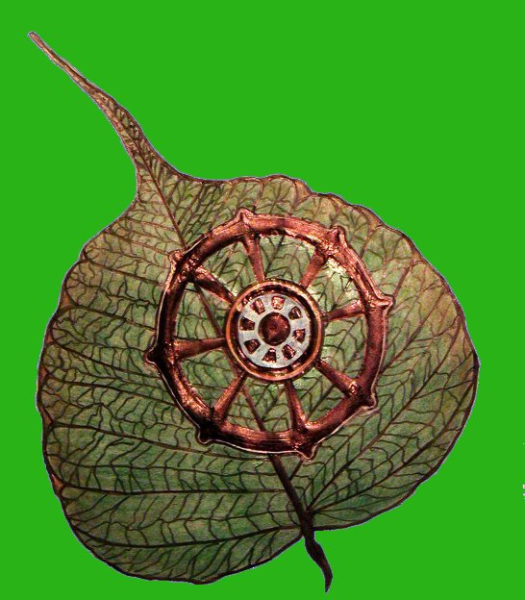
United International Buddha Dhamma Society
and
Dhamma Sukha Meditation Center
LOGO

In 2005, DSMC began a temporary ordination program for two weeks with meditation training. This was a new project to offer this inside the United States.
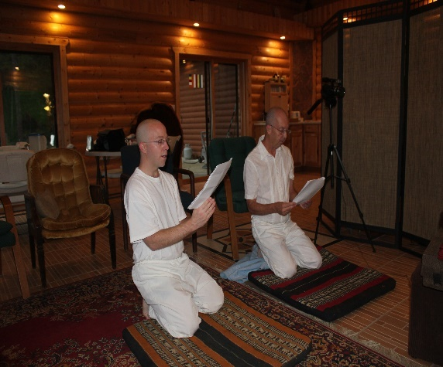  3 X We come Venerable Sir to request robes | 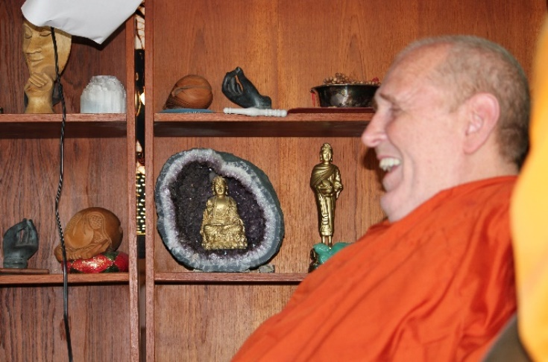  We are finding friendly instructions and support.
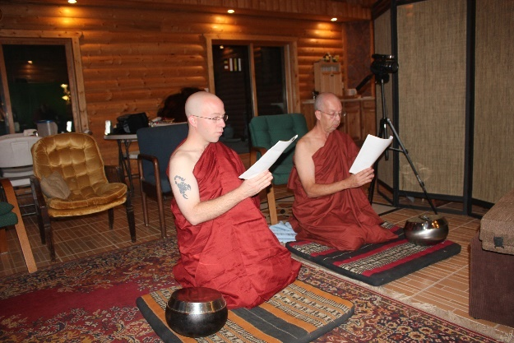  We take our vows in complete sincerity to obey & practice and follow the precepts….  And the journey begins. | 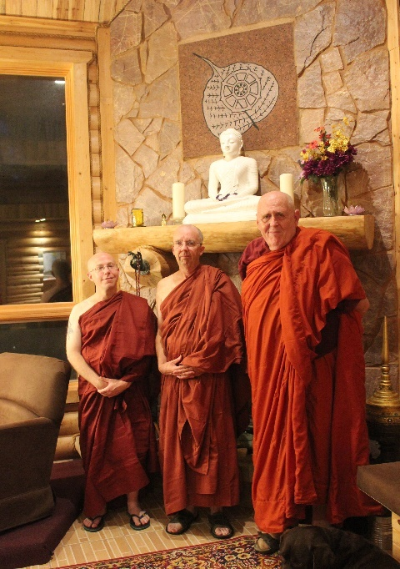

x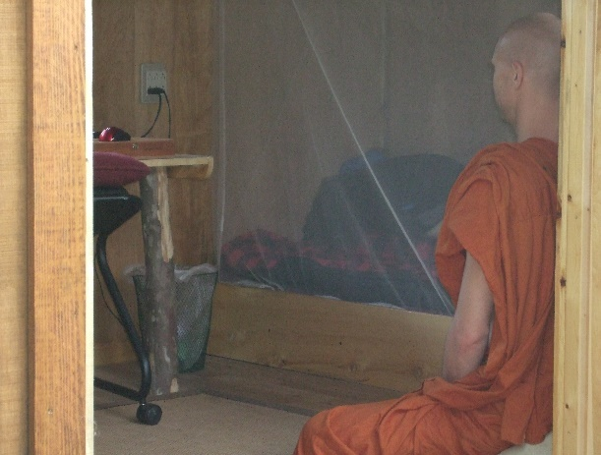 | Monks of higher ordination live in not too tight but not too loose training cabins during training. They do have electric light, very small A/c and fans, bed, desk, bookcase, and robes hooks, and small deck porch.
[ Need to find picture of U Jatika for here ] | Monastics of higher ordination can come and contribute some needed teaching in exchange for requisites and meditation coaching, or have a private space for completing a thesis and using the Library. But all visiting monks should make arrangements to stay for a full vassa period starting on the June or July full moon. They may occasionally help with basic kinds of teaching, give short workshops, And certainly have a chance to refine their English speaking skills. They may also learn how to present an effective set of Dhamma Talks on Four primary dhamma ssubject in English by the end of the Vassa. This is very helpful. Members of the Burmese community, Sri Lankan Community, and Thich Hat Han communities have used this program so far. as.
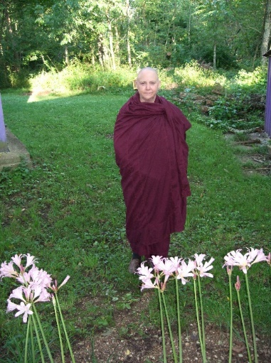 | <<<<<<<Samaneri Sister Khema began teaching in 2009..  The Forest becomes our home  and everything in it supports us……

Butterflies, Turtles, Squirrels, Chipmunks, Bird, Hawks, Falcons and mice. If you learn your metta correctly, even the Bees won’t sting you in your equanimity. | 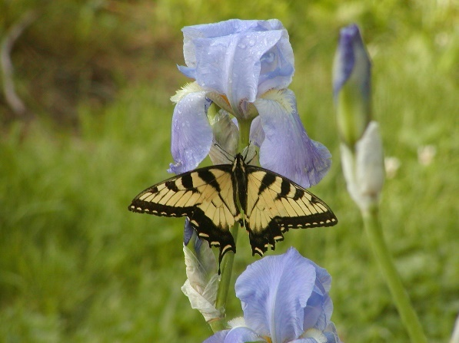

And yes we did finish a wonderful New 8- sided Dhamma Hall in 2011 to hold up to 100 people!
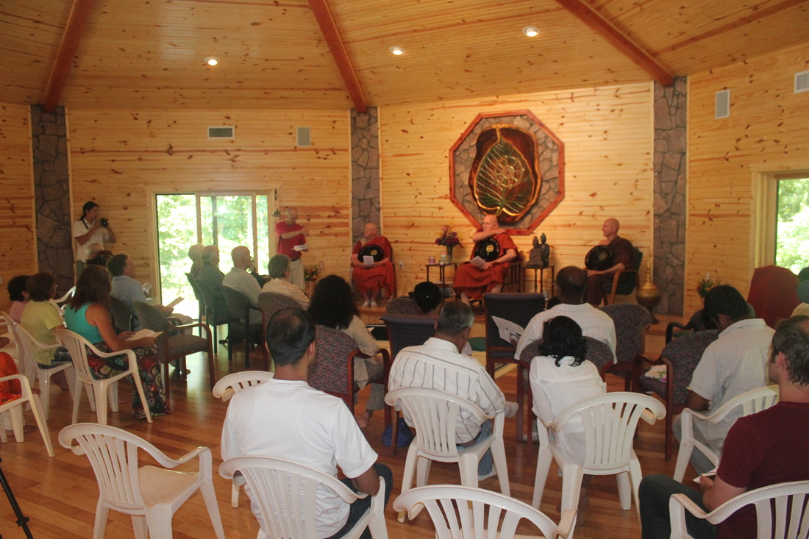

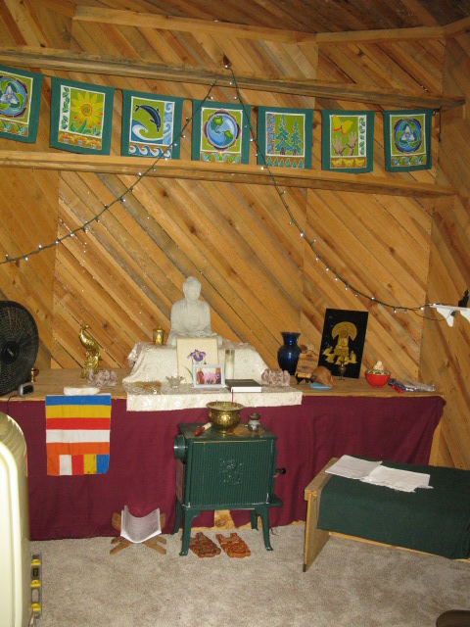 | Eventually, we needed a small room for private counseling and family blessings when visitors appeared. The original first kuti was turned over to become a small forest shrine. This was the perfect solution at that time. Including a small portable A/C, a heater and a nice carpeted floor for prayers and meditation space  at other times. It was perfect.  Ven. Sister Khema
One cannot dis miss a picture of such balance, which I shall never get a chance to take again! It is my favorite happy tree and happy monk in South Korea- post retreat about 1 hour from Seoul. SK

Once you are a temporary monastic, it doesn’t entirely mean you have to become trapped only in your little kuti! You have more space to realize on the property to move around while you do walking meditation or sit in many quiet places quietly. Pictures can say it all.

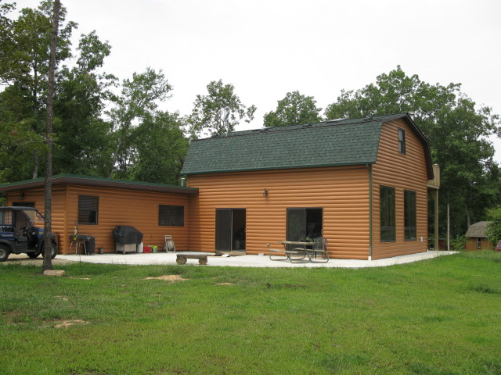 | New Kitchen  Dining Hall  Library  And All Purpose Building
Surrounded by concrete walkways and today having lovely gardens donated as well surrounding it. | 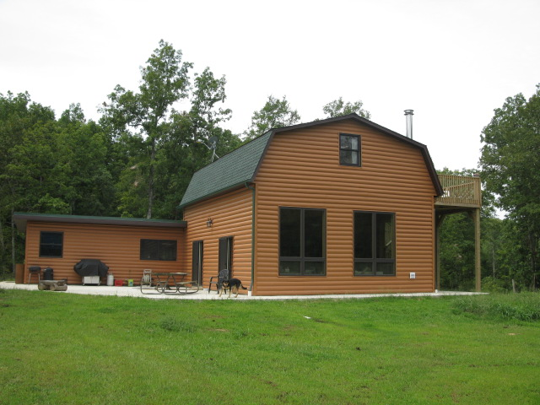
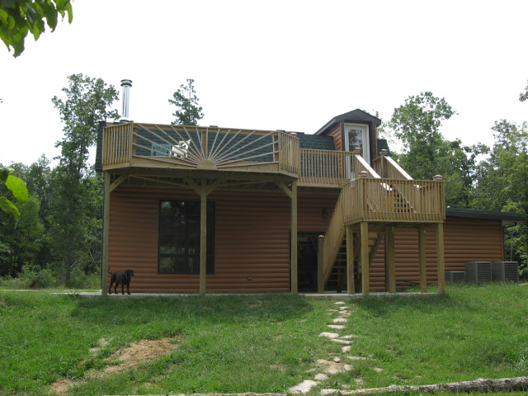 | An all-day place in the shade beneath an upper deck that is higher than most of the bugs! With a stairwell leading to the upper library.
Interior of the Dining Hall >>> | 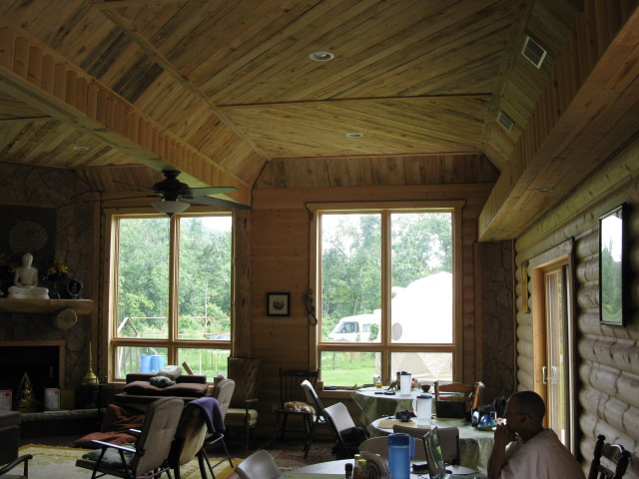

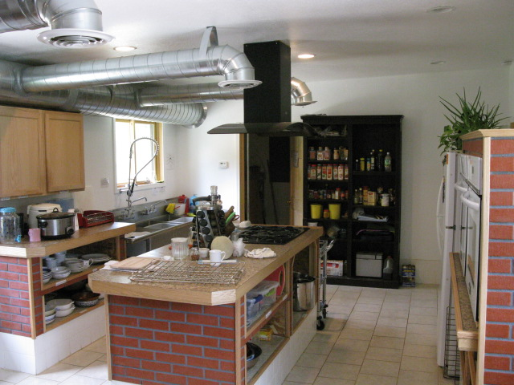 | <<<Commercial Kitchen is just right for pot luck meals and larger events.
A friendly kitchen has space for Food Storage shelving and further 5 preceptor eating area too >>> | 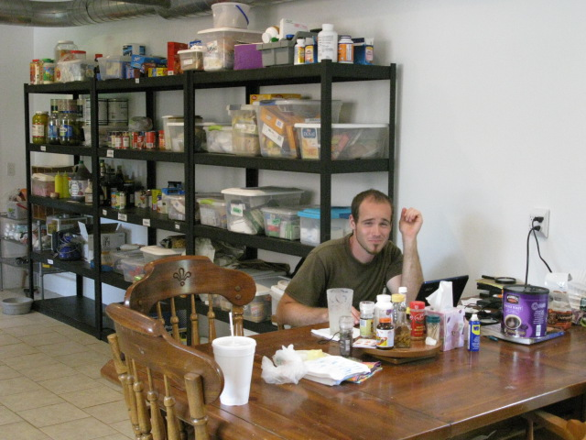

Our Retreat manager, Mr. David Johnson moved from California to build a handcrafted small permanent residence on the land and to serve as a Kappiya for Bhante V as well himself.

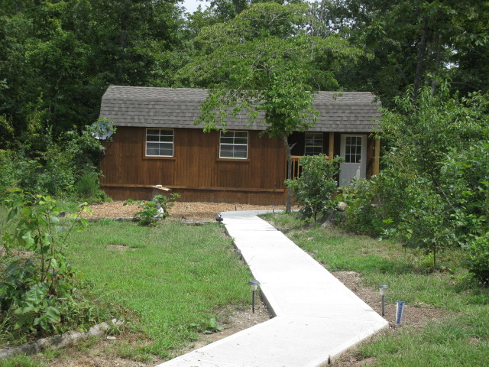 | <<<<Retreat Manager’s cabin. This is where Dhamma Talk videos and tapes are edited before posting onto the internet and work is completed on the  www.dhammasukha.org website.
#1. The Wendle Wendt Cabin was our first donated student Cabin to be completed. It was donated for people to practice Spiritual Meditation when he died and is still serving us well. | 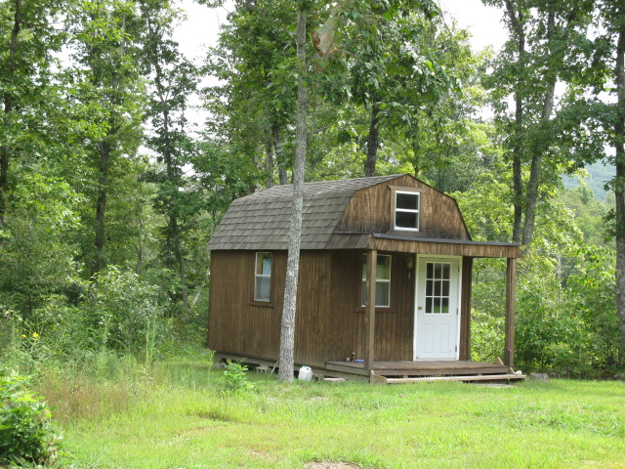
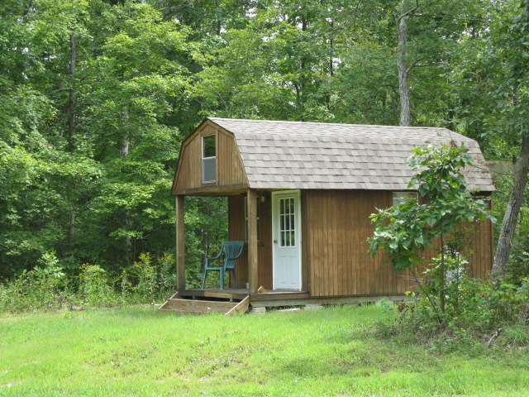 | #2 cabin is the Women’s Cabin and was donated by Women also to bring good Female energy into one place.
# 3. “Forest Tree Cabin” is our third student’s cabin built >>>> | 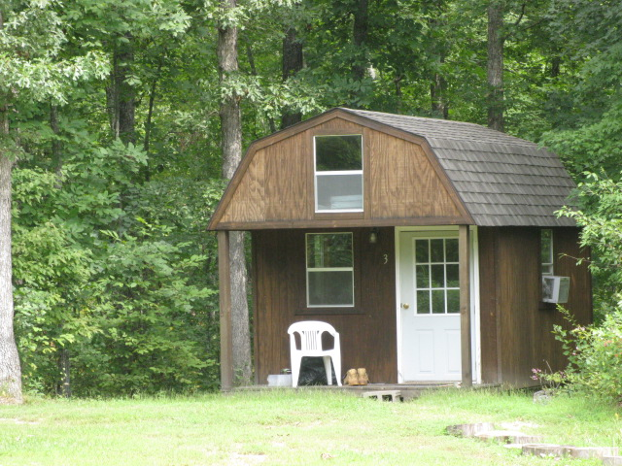
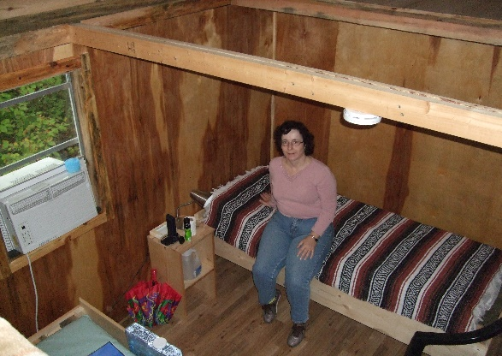 | Interior of small log cabin temple and Family counseling cabin
# 5. Universal Peace Cabin completely handicap accessible for any soldier coming home who wants to use it, donated by the New York Burmese Temple community in 2006. This was to be the first of two cabins for a physically challenged persons to have a place to rest with some support. We attempted to include a flexible hospital bed, low closet, a by a window desk, Universal height plugs and switches and allow space for a companion to sleep in also. There is a carpeted loft too. | 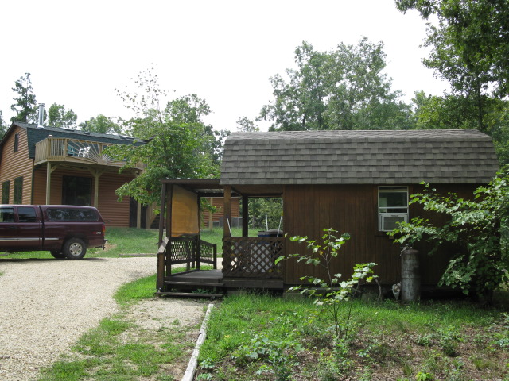
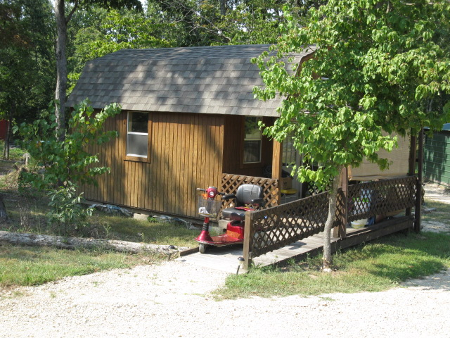 | There is a ramp from the front porch. There was intention to also build a raised box hobby garden to work in from beside a wheel chair outside. For growing flowers or herbs. A electric motorized Scamp con donated for use on the upper area walkways.

Behind the kitchen, 2 gardens are just waiting for the care of a loving creative gardener to set them up right with fresh top soil and herbs. A shade awning may be installed to help protect them from heavy sun. | 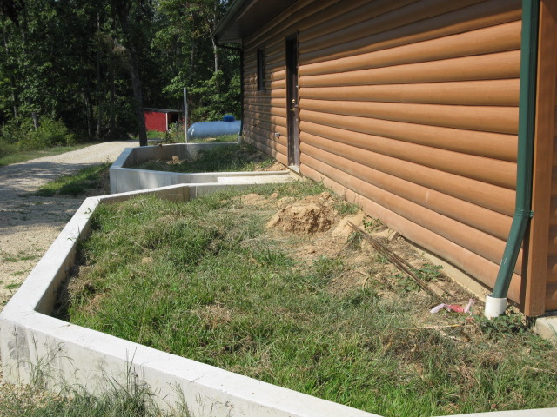
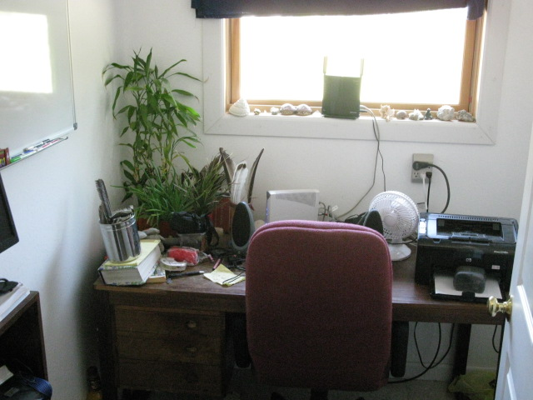 | Our Kitchen office
A noonday ride to check out conditions of all walking paths ============== | 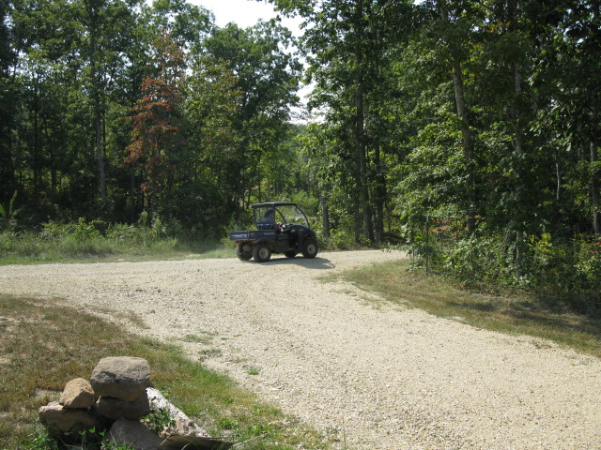

Dear Dhamma Friends,
I hope you liked this little journey online. Drop me aline if you would like to see more.
Thanks for taking the time to visit some of our center and activities. I am sure that more pictures will trickle in over time.
To reserve time for a visit or a retreat at DSMC you need only to contact Mr. David Johnson who is our retreat manager onsite.
Country code (+01) (573) 340- 1481

You may look more deeply in www.dhammasukha.org to find coaching opportunities, over 400 Dhamma talks online and full retreats you can follow to try out the practice of Tranquil Wisdom Insight Meditatoin, which in the practice we teach. Inside the website, you will find audio recordings to download, a list with accompanying transcripts you can collect and Books in many languages now too.
If you want to help support this effort in labor, funding, or supportive words of Loving Kindness and encouragement, please write to David or contact sisterkhema@dhammasukha.org and I will be happy to help you move in the right direction for what you need. If you wish to suppoort in any manner our ongoing project, the continued quest to return this LIVING DHAMMA PRACTICE into thehands of all people and monastics everywhere.
Metta and smiles to you all.
Rev. Sister Khema

